PROJECT PLANNING PHASE
AI StudyBuddy – AI-Powered Personalized Study Assistant
Date | 29 September 2026 | Team ID | SWTID-2026-4296
Project Name | AI StudyBuddy | Maximum Marks | 5 Marks

1. Product Backlog, Sprint Schedule, and Estimation (4 Marks)

Product Backlog
Project Name: AI StudyBuddy Team ID: SWTID-2026-4296
Sprint | Functional Requirement (Epic) | User Story Number | User Story / Task | Story Points | Priority | Team Members
Sprint-1 | Project Setup | USN-1 | As a developer, I can set up the application environment so that the system can process user requests. | 2 | High | AI StudyBuddy Team (SWTID-2026-4296)
Sprint-1 | Database | USN-2 | As a developer, I can connect the application to MongoDB so that user information and learning resources can be stored persistently. | 2 | High | AI StudyBuddy Team (SWTID-2026-4296)
Sprint-1 | Configuration | USN-3 | As a developer, I can configure environment variables so that database credentials and AI API keys remain secure. | 1 | High | AI StudyBuddy Team (SWTID-2026-4296)
Sprint-1 | Authentication | USN-4 | As a user, I can register using my name, email, and password so that I can create an account. | 2 | High | AI StudyBuddy Team (SWTID-2026-4296)
Sprint-1 | Authentication | USN-5 | As a user, I can log in using my credentials so that I can access personalized study resources. | 2 | High | AI StudyBuddy Team (SWTID-2026-4296)
Sprint-1 | Authentication | USN-6 | As an authenticated user, I can access protected resources so that my learning data remains secure. | 2 | High | AI StudyBuddy Team (SWTID-2026-4296)
Sprint-2 | Study Material Management | USN-7 | As a student, I can upload PDFs, notes, and text documents so that I can use my study materials in the application. | 3 | High | AI StudyBuddy Team (SWTID-2026-4296)
Sprint-2 | Document Processing | USN-8 | As a student, I can extract text from uploaded study materials so that the content can be processed by AI. | 2 | High | AI StudyBuddy Team (SWTID-2026-4296)
Sprint-2 | AI Summarization | USN-9 | As a student, I can generate concise summaries so that I can understand lengthy study materials quickly. | 3 | High | AI StudyBuddy Team (SWTID-2026-4296)
Sprint-2 | Flashcard Generation | USN-10 | As a student, I can generate flashcards automatically so that I can revise important concepts efficiently. | 2 | High | AI StudyBuddy Team (SWTID-2026-4296)
Sprint-2 | Quiz Generation | USN-11 | As a student, I can generate practice quizzes so that I can test my knowledge before examinations. | 2 | High | AI StudyBuddy Team (SWTID-2026-4296)
Sprint-3 | Study Planning | USN-12 | As a student, I can create a personalized study plan based on my examination schedule and available time. | 3 | High | AI StudyBuddy Team (SWTID-2026-4296)
Sprint-3 | Resource Management | USN-13 | As a student, I can save and retrieve summaries, flashcards, quizzes, and study plans so that I can access them later. | 3 | High | AI StudyBuddy Team (SWTID-2026-4296)
Sprint-3 | User Profile | USN-14 | As an authenticated user, I can view my profile so that I can access my account information. | 1 | Medium | AI StudyBuddy Team (SWTID-2026-4296)
Sprint-3 | API Validation | USN-15 | As a developer, I can validate user inputs and uploaded files so that invalid requests are rejected. | 2 | High | AI StudyBuddy Team (SWTID-2026-4296)
Sprint-3 | Error Handling | USN-16 | As a developer, I can handle application and AI service errors consistently so that users receive meaningful error messages. | 2 | Medium | AI StudyBuddy Team (SWTID-2026-4296)
Sprint-3 | Testing | USN-17 | As a tester, I can test authentication, material processing, AI features, and study planning so that the system functionality can be verified. | 3 | High | AI StudyBuddy Team (SWTID-2026-4296)
Total Estimated Story Points: 37

Sprint Schedule
Sprint-1: Project Setup and Authentication
Duration: 6 Days | Planned Start Date: 01 Sep 2026 | Planned End Date: 06 Sep 2026 | Story Points: 11
Objectives: Project setup, database configuration, environment variables, registration, login, and protected access.
Sprint-2: Study Materials and AI Features
Duration: 6 Days | Planned Start Date: 07 Sep 2026 | Planned End Date: 12 Sep 2026 | Story Points: 12
Objectives: Study material upload, text extraction, AI summarization, flashcard generation, and practice quizzes.
Sprint-3: Study Planning, Resource Management, and Testing
Duration: 6 Days | Planned Start Date: 13 Sep 2026 | Planned End Date: 18 Sep 2026 | Story Points: 14
Objectives: Personalized study plans, saved resources, profile access, validation, error handling, and integration testing.
Planning note: Sprint dates and story-point completion figures are planning targets. Update them to reflect the actual development schedule and completed work.

2. Project Tracker, Velocity & Burndown Chart (4 Marks)

Project Tracker
Sprint | Total Story Points | Duration | Sprint Start Date | Sprint End Date (Planned) | Story Points Completed (Planned Target) | Sprint Release Date (Actual)
Sprint-1 | 11 | 6 Days | 01 Sep 2026 | 06 Sep 2026 | 11 (Target) | To be updated
Sprint-2 | 12 | 6 Days | 07 Sep 2026 | 12 Sep 2026 | 12 (Target) | To be updated
Sprint-3 | 14 | 6 Days | 13 Sep 2026 | 18 Sep 2026 | 14 (Target) | To be updated
Total | 37 | 18 Days | — | — | 37 (Target) | —
Note: The planned completed story points are targets, not verified actual results. Enter the actual completion and release dates after each sprint.

Velocity
Formula: Average Velocity = Total Story Points Completed / Total Sprint Duration
For AI StudyBuddy (planned estimate):
Total Estimated Story Points = 37
Total Sprint Duration = 18 Days
Average Velocity = 37 / 18 = 2.06 Story Points per Day
Average Team Velocity = 2.06 Story Points per Day (planned). Actual team velocity should be calculated using story points completed during the sprints.

Burndown Chart
The following is a planned burndown schedule for the 37-point backlog across 18 days. Actual remaining points may differ according to development progress.
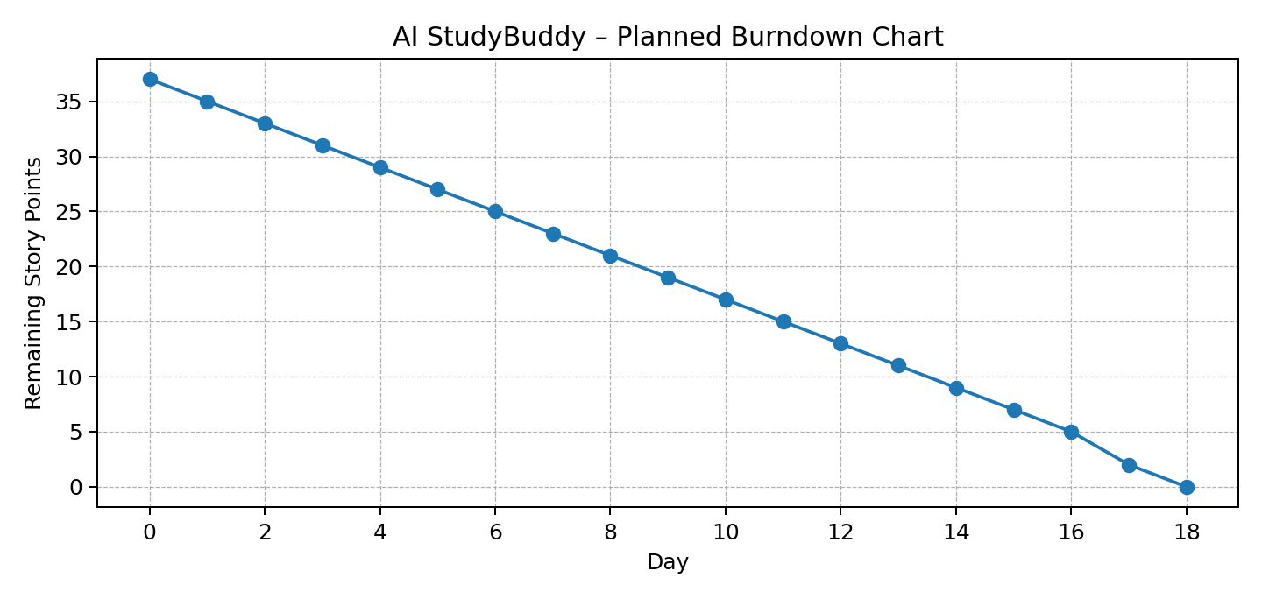
Day | Remaining Story Points
Day 0 | 37
Day 1 | 35
Day 2 | 33
Day 3 | 31
Day 4 | 29
Day 5 | 27
Day 6 | 25
Day 7 | 23
Day 8 | 21
Day 9 | 19
Day 10 | 17
Day 11 | 15
Day 12 | 13
Day 13 | 11
Day 14 | 9
Day 15 | 7
Day 16 | 5
Day 17 | 2
Day 18 | 0

Burndown Chart Explanation
The burndown chart represents the remaining story points during AI StudyBuddy development. The initial backlog contains 37 story points. As the team completes tasks such as authentication, study material processing, AI summarization, flashcard generation, quiz generation, and personalized study planning, the remaining story points decrease. The planned target is to complete the backlog within 18 days. The actual burndown may vary depending on task complexity, technical issues, and team progress.

